.

Nursery to P1 Transition Challenges – 8th June

If you would like to share pictures of your learning, please post these in your child’s online learning journals


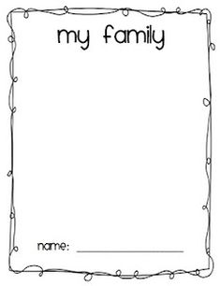

All About Me


My name is: I am ____ years old

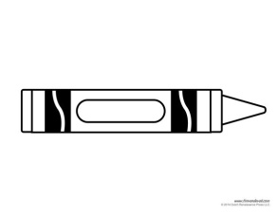

My favourite colour is __________

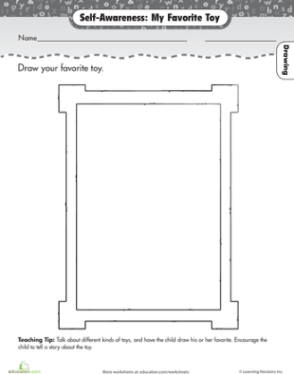

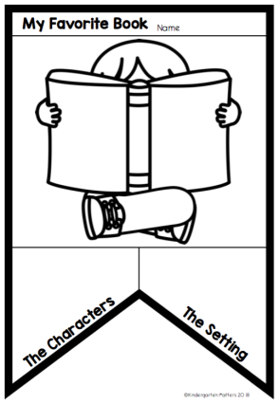

One thing I like is….

When I grow up I want to be…

Something I don’t like is….

